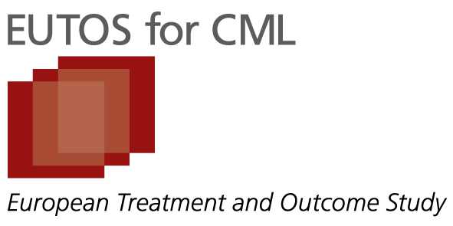
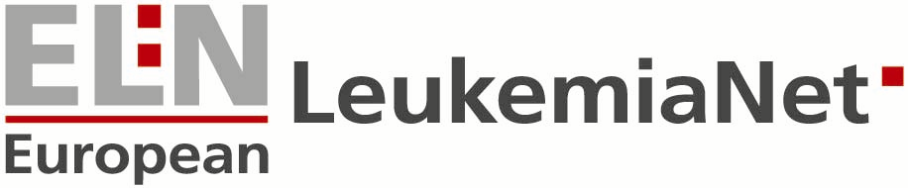
Pocket Card
Recommendations
from the European LeukemiaNet for the Management of CML

Order Form

Please fill in the form and fax to
+49 (0) 621-383 6968

or send via Email to
nmc@leukemia-net.org

Ship to (please use capitals to fill):
Name: ……………………………..
Institution: ……………………………..
Address: ……………………………..
……………………………..
……………………………..
Email: …………………………….. (important for contact!)
Invoice address:
(if different from shipping address)

……………………………………..

………………………………….......

……………………………………...

……………………………………...

Email: (important for contact!)
……………………………
Pocket Cards:

1 Pocket Card (free)

5 Pocket Cards (free) 50 Pocket Cards (price upon request)

10 Pocket Cards (free) 100 Pocket Cards (price upon request)

15 Pocket Cards (free) (specify the number of Pocket Cards required: ________)

Please send me the indicated number of Pocket Cards.

---------------------------------------------
Date, Signature

